A000- **Asia-China-Dragon Brick-Ming Dyn-1300 CE**

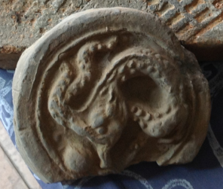

**Asia-China-Dragon Brick-Ming Dyn-1300 CE**

**Case No.: 5**

**Accession No.**

**Formal Label: Asia-China-Dragon Brick-Ming Dyn-1300 CE**

**Display Description:**

**LC Classification:**

**Date or Time Horizon:**

**Geographical Area:**

**Map:**

**GPS coordinates:**

**Cultural Affiliation:**

**Media:**

**Dimensions:**

**Weight:**

**Condition: original**

**Provenance: Dai Qing, 2003**

**Discussion:**

**References:**